Title
Fact Sheet on Prevention and Management of Dengue Fever in Hospital
Purpose
To provide update information on the prevention and management of Dengue Fever in hospital. The key foci are rapid detection and notification of patients presenting with compatible clinical features, patient management and mosquito control in the hospital environment.

Epidemiology
Dengue Fever (DF) is caused by four closely related, but antigenically distinct, virus serotypes (DEN-1, DEN-2, DEN-3, and DEN-4), of the genus Flavivirus. Infection with one of the serotypes does not provide protection to other serotypes. Mosquito vectors, mainly Aedes aegypti and Aedes albopictus transmit the virus. Aedes albopictus, a less efficient epidemic vector than Aedes aegypti, is widely distributed in Hong Kong.

Incubation Period
From 3 to 14 days, but commonly 4-7 days

Clinical Manifestation
a) DF is a self-limited acute febrile illness accompanied by headaches, musculoskeletal pain, and skin rash. It is usually asymptomatic in children, but more severe in adults. For symptomatic cases, fever develops after the incubation period and progress rapidly with severe musculoskeletal pain. Skin rash, retro-orbital pain, anorexia, nausea, and vomiting are common. Minor bleeding from the gums and gastrointestinal tract, epistaxis and hemoptysis can also occur.
b) Dengue hemorrhagic fever (DHF) is infrequent but more likely to occur in secondary infections. It is characterised by four major clinical manifestations: high fever, hemorrhagic phenomenon, hepatomegaly and circulatory failure. Moderate to marked thrombocytopenia, haemoconcentration, hypoproteinaemia, hyponatraemia, and elevated level of aspartate aminotransferase (AST) are distinctive laboratory findings in DHF. There is no specific treatment for DHF, but with prompt supportive treatments, fatalities are low.
c) Dengue shock syndrome (DSS) patients progress to shock usually between the third and seventh day of illness, at the time of or shortly after the fall in temperature. Signs of circulatory failure, restlessness and abdominal pain are frequently observed.
d) Differential diagnoses: Malaria, Typhoid fever, Leptospirosis, Meningococcaemia, Rickettsial infections and other viral illness especially Measles, Rubella, Influenza and viral hemorrhagic fevers.

Case Definition (see annex I for details)

a) Suspected case: An acute febrile illness with compatible clinical symptoms which include intense headache, retro-orbital pain, myalgia, arthralgia, skin rash, hemorrhagic manifestations or leucopenia.

b) Probable case: A clinically compatible case with positive IgM serology or antibody titre of ≥1280 to DF.

c) Confirmed case: A clinically compatible case with positive isolation of dengue virus from patient samples, detection of dengue virus genomic sequences or four fold rise in antibody titres to DF.

Preventive & Control Measures
a) Anti-mosquito Control Measures: Hospital management should make sure a regular program in the elimination of mosquito in hospital is strictly followed. Particular attention has to be given to patient areas to achieve a mosquito-free environment, especially in non-air-conditioned wards where DF patients might be admitted. The removal of any collection of stagnant water in the outdoor vicinity of the hospital is critical to reduce the chance for transmitting DF. Continued education of staff and the use of a checklist (see Annex 2) are encouraged.

b) Early Case Detection and Notification: Early detection of cases is most important in the control of any community outbreak. Suspected or confirmed cases of Dengue Fever should be reported to both HAHO CCIC Secretariat (Fax no. 2881 5848) and DH regional offices promptly for follow up investigations. (Please refer to Annexes 3 and 4).

c) Patient Management: A high index of suspicion should be given to patients with recent exposure to DF endemic countries or local regions with reported cases.
  - Suspected Cases:
    - When a case of DF is suspected, blood test for Dengue virus serology should be requested. Serological test for diagnosis of DF is time dependent, antibody might fail to develop at the early phase of the illness (up to day six after symptom onset) and convalescent-phase serum sample has to be drawn for testing;
    - If the patient presents six or more days after symptom onset, the serological test for IgM antibody should be done without delay;
    - Arrangement should be made with the hospital laboratory for sending out specimen to DH laboratory for testing;
    - The patient should be kept in air-conditioned ward or area with mosquito control pending confirmation/exclusion of the diagnosis.

  - Probable/Confirmed cases: Patients should be managed with supportive care. Aspirin should be avoided. Appropriate infection control measures (Universal Precautions) should be followed. Early detection for shock and the development of DHF with proper fluid/platelet replacement is important.

Infection Control Measures
a) Isolation of patients of DF/DHF is not indicated (CDC).
b) In non-air conditioned wards, proper mosquito control measures should be implemented.
c) Dengue fever is not directly transmitted from person to person.
d) Dengue fever is a notifiable disease.

Reference
a) CDC Dengue Fever Home Page (http://www.cdc.gov/ncidod/dvbid/dengue/index.htm)
b) Department of Health Information Sheet on Dengue Fever / Dengue Haemorrhagic Fever, September 2001 (http://www.info.gov.hk/dh/useful/ltod/fs_dengue.htm)
c) World Health Organisation advice on managing patients with DHF (http://www.who.int/emc/diseases/ebola/Denguepublication/index.html)

Frequently Asked Questions

a) What action should be taken in the event of an upsurge of Dengue Fever patients?
  - An upsurge of Dengue fever cases may be prompted by the current active surveillance in place in DH and HA, either due to the increase in attendance at GOPD, private practitioners or the A&E departments.
  - Coordination of response actions within HA is done both centrally and at the hospital level.
  - The HAHO Duty Officer and Duty Microbiologists, are responsible for the overall case surveillance within hospitals, information update to hospital management and frontline staff, coordinate with the BTS in preparation for an increased demand for blood products, liaison with DH for referring cases for admission and arrangement of patient diversion, if necessary.
  - The hospital management would, upon the trend of patient attendance and hospital admissions, see to the need for activation of hospital contingency plans in providing accommodation and care for patients through various means, such as arrangement of ward areas and patient transfer within cluster hospitals. Appropriate manpower would have to be mobilized in various departments in the management of large number of admissions, notably the medical, paediatric and intensive care units.
  - The hospital infection control teams are responsible for coordinating case notification, confirmation of diagnosis, information dissemination and communication with the Secretariat of the Central Committee on Infection Control during the outbreak.
  - As Dengue fever patients do not require special isolation facilities, all hospitals are capable of providing patient care. There is no need to designate a hospital for referral of Dengue fever patients.
  - Based on the epidemiological and clinical experience gathered from the recent local cases, most patients of Dengue infections would be uncomplicated primary infections.
  - The mainstay of treatment for Dengue fever patients is supportive with close monitoring of vital signs. Recovery generally takes place within a week. The hospital stay is expected to be 1-2 weeks, with the possibility of step down care in convalescent or subacute hospitals once the patient is stabilised prior to discharge.

b) What is the approach in AED when patients worry about having contracted Dengue and demand testing?
  - AED should attend to patients based on clinical needs;
  - when patients are symptom-free, they should be reassured.

c) What if the patient is running a fever and worry about having contracted Dengue and demand testing?
  - look for signs and symptoms of Dengue Fever;
  - check also for other common causes of fever, e.g. URTI, UTI etc.,;
  - consider differential diagnosis of Dengue fever, such as influenza, scrub typhus, malaria, measles, meningococcaemia, typhoid fever etc.;
  - evaluate the patient clinically, in particular for high fever, conscious level, blood pressure, hydration status, signs of bleeding and increased vascular permeability, severe abdominal pain or prolonged vomiting and early warning signs of shock;
  - check haematocrit and/or platelet level, if indicated;
  - take blood for Dengue Fever testing when circumstantial factors such as mosquito bite, working in construction sites, epidemiological link to local cases etc. are present.

d) What to do when I suspect a patient suffering from Dengue Fever?
  - make sure the case definition for “Suspected Dengue Fever” is fulfilled, i.e. an acute febrile illness characterized by intense headache, retro-orbital pain, myalgia, arthralgia, rash, leucopenia or haemorrhagic manifestations;
  - hospitalise the patient for further investigation and management;
  - take blood for clinical and virological laboratory tests (5 ml of clotted blood) to confirm/exclude Dengue fever;
  - use the correct laboratory request from for Dengue testing; (DH-161 or DH1293/HA1293 or other appropriate forms used in your hospital)
  - write down clearly on the request form the date of onset, a detailed clinical history, symptoms and signs to help the laboratory to decide whether PCR should be performed on the specimen.
  - Note: Dengue antibody, IgM, might not develop within the first 6 days of onset of fever, and a 2nd convalescent serum sample has to be collected for the testing;
  - deliver the specimens to DH laboratory through the hospital laboratory or directly, without delay;
  - notify DH regional offices (see below) and HAHO (fax:2881 5848) ;
  - during weekends, public holidays or after office hours, urgent notification of suspected cases to DH duty Medical Control Officer (MCO) at 7116 3300 (call 9179).

Regional Office | Fax | Tel
Hong Kong | 2572 7582 | 2691 8729
Kowloon | 2375 8451 | 2199 9158
New Territories East | 2699 7691 | 2158 5107
New Territories West | 2439 9622 | 2615 8571

e) When patients presenting with just fever but lacking other clinical compatible symptoms and signs of Dengue fever, what are the indications for admission?
  - The indications for admission are :
- Altered conscious level (irritability or somnolence)
- High fever or abrupt change from fever to hypothermia
- Haemorrhagic manifestations
- Severe abdominal pain or prolonged vomiting
- Warning signs of shock (even without profound shock) eg., tachycardia
- Platelet < 100 x 10⁹/L
- High hematocrit

  - If the patient is stable after clinical evaluation, but Dengue fever ought to be ruled out because of presence of risk factors such as mosquito bite, working in construction sites, epidemiological link to local cases etc.,
    - take blood for Dengue antibodies and virus;
    - the patient should be advised to rest at home;
    - advise the patient To Come Again if symptoms of Dengue Fever arise;
    - arrange follow up for the patient.

f) How would the results on Dengue Fever be reported to the hospital?
  - for a confirmed positive Dengue Fever result, DH would inform, by phone, the requesting doctor or the hospital laboratory immediately;
  - therefore, it is important to put down clearly on the request from the contact phone number for such purpose;
  - there is no need for us to chase for urgent results of our patients.

g) Should patients be referred to PMH?
- Dengue fever patients do not require isolation;
- they should be managed in air-conditioned ward or area with mosquito control pending confirmation/exclusion of the diagnosis;
- No need to refer patients to PMH for such purpose.

h) Should I notify every case when blood is taken for Dengue fever?
- notify when Dengue fever is suspected based on the case definition, i.e. an acute febrile illness characterized by intense headache, retro-orbital pain, myalgia, arthralgia, rash, leucopenia or haemorrhagic manifestations.

i) What to do when I received a positive Dengue fever result?
- inform the hospital Infection Control Team of the case for co-ordination in infection and environmental control.

j) Where can I get advice on the mosquito control?
- follow the checklist on mosquito control as outlined in the HA Guideline on Dengue Fever;
- for further information or technical assistance, you can phone FEHD enquiry hotline at 2319 8596.

k) Can a person donate blood if he/ she has contracted Dengue Fever?
- Under the BTS’s current donor selection criteria, an individual will be deferred for blood donation if he/ she has history of confirmed Dengue Fever.
- If a person is unsure of history of Dengue Fever, he/ she is required to reveal any history of fever and flu like symptoms in the preceding two weeks to the BTS staff during the donor health history enquiry before blood donation. He/ she is also advised to report any symptoms within 2 weeks after giving blood.

Annex 1 : Case Definitions:

Case Definition of a Suspected DF case for notification
An acute febrile illness characterized by intense headache, retro-orbital pain, myalgia, arthralgia, rash, leucopenia or haemorrhagic manifestations.

Case definition of DF
      - Confirmed case: A clinically compatible case with laboratory confirmation.(see below)
      - Probable case: A clinically compatible case with supportive serology. (see below)

Criteria for laboratory confirmation:
- Isolation of dengue virus from serum and/or autopsy samples; or
- Demonstration of a fourfold or greater change in antibody titers to one or more dengue virus antigens in paired serum samples; or
- Detection of dengue virus genomic sequences in autopsy tissue, serum or cerebrospinal fluid samples by polymerase chain reaction (PCR).

Supportive serologic findings:
An antibody titer of ≥1280 or a positive IgM antibody test on a single late acute- or convalescent-phase serum specimen to one or more dengue virus antigens.

Case definition of DENGUE HAEMORRHAGIC FEVER (DHF)
All of the following criteria must be present-
- Fever, or history of acute fever, lasting 2-7 days;
- Haemorrhagic tendencies;
- Thrombocytopaenia (≤100 x 10⁹/L); and
- Evidence of plasma leakage.

Haemorrhagic tendencies:
- A positive tourniquet test; or
- Petechiae, ecchymoses or purpura; or
- Bleeding from the mucosa, gastrointestinal tract, injection sites or other locations; or
- Haematemesis or melaena.

Plasma leakage:
- A rise in haematocrit ≥20% above average for age, sex and population; or
- A drop in haematocrit following volume-replacement treatment ≥20% of baseline; or
- Signs of plasma leakage such as pleural effusion, ascites and hypo-proteinaemia.

Case definition of DENGUE SHOCK SYNDROME (DSS)
In addition to the above four criteria for DHF, there is evidence of circulatory failure as follows-
- Rapid and weak pulse, and narrow pulse pressure (<20 mmHg); or
- Hypotension for age, and cold, clammy skin and restlessness.
Annex 2

CHECKLIST OF ANTI-MOSQUITO MEASURES

防止蚊患核對表

INDOOR ENVIRONMENT室內環境

- Discarded bottles, cans and empty lunch boxes:
被棄置的玻璃瓶、汽水罐和空飯盒：
- Keep in containers with well-fitted cover.
將被棄置的玻璃瓶、汽水罐和空飯盒放於有蓋垃圾桶內。
- Air conditioner trays:
冷氣機托盤:
- Remove or properly drain away water.
每星期清除或適當地排放托盤中的積水。
- Water storage containers:
貯水容器:
- Cover storage tanks, drums and jars used for water storage with tight lids or screens.
把所有貯水容器包括槽、罐、瓶蓋好。
- Flower vases:
花瓶：
- Change water in vases at least weekly.
每星期最少更換花瓶水一次。
- Saucers for ornamental potted plants:
花盆底的盆碟：
- Drain away water immediately after watering.
切勿讓花盆底的盆碟積水。
- Floor drains:
地面的溝渠：
- Clear floor drains of debris at least weekly to prevent choking.
每星期將地面溝渠的碎物殘骸最少清理一次，保持溝渠暢通。
- Uneven floor:
凹陷的地面：
- Sweep regularly at least weekly to remove collected water from scrubbing
每星期最少清掃凹陷的地面一次，以防積水。

Remark 備註:

Ref : 2002 Anti-mosquito campaign pamphlet from Food and Environmental Hygiene Department

OUTDOOR ENVIRONMENT室外環境

- Saucers for ornamental potted plants:
花盆底的盆碟：
- Drain away water immediately after watering.
切勿讓花盆底的盆碟積水。
- Tree holes and bamboo stumps:
樹洞及竹端：
- Fill with sand, mud or concrete as appropriate.
用幼沙、泥或混凝土填塞。
- Roof gutters and surface drainage channels:
屋頂排水溝及坑道：
- Clear leaves and debris regularly at least weekly.
每星期最少清理樹葉和碎物殘骸一次。
- Discarded bottles, cans and empty lunch boxes:
被棄置的玻璃瓶、汽水罐和空飯盒：
- Keep in containers with well-fitted cover.
將被棄置的玻璃瓶、汽水罐和空飯盒放於有蓋垃圾桶內。
- Rubbish:
垃圾：
- Keep in disposable plastic bags which should then be tied up at the openings and kept in containers with cover.
將垃圾放於用完即丟棄的膠袋內, 把開口封好, 並放於有蓋垃圾桶內。
- Junk:
廢棄的舊物：
- Keep in junk collection areas with cover.
將廢棄的舊物置於有遮蓋的收集地方。
- Scrubbing junk collection areas only when the junk has been cleared.
當所有廢物經適當清理後，收集區才可進行擦洗行動。
- Disused tyres as anti-bumping device:
作為防撞裝置之廢棄的車胎：
- Puncture with big holes.
把車胎鑽穿，以防積水。
- Preferably replace anti-bumping device by marking on the floor.
利用地面上的記號達到防撞功能。
- Water storage containers:
貯水容器:
- Cover storage tanks, drums and jars used for water storage with tight lids or screens.
把所有貯水容器包括槽、罐、瓶蓋好。
- Ornamental fountain:
裝飾的噴泉：
- Chlorinate ornamental fountain or populate fountain with larvivorous fish.
使用氯化泉水方法或者飼養以幼蟲為食物的魚。

Flowchart for Surveillance of Dengue Fever
Annex 3
Acknowledgement of notification

Suspected/Confirmed
Dengue Fever Cases
Notification completed

- DH (Form 2 - Quarantine & Prevention of Disease Ordinance [Cap.141])
(Annex 3a)

and

(2) Report form for Dengue Fever (clinical data), (Annex 3b)
Fax to Secretariat of Central Committee of Infection Control (CCIC)

Fax no.: 2881 5848

Infection Control Measures
Cases review by Infection Control Officer
Follow up with ICNs
HAHO Subject Officer

Duty Microbiologist
Daily notification to DH Headquarter via e-mail
Investigation of cases
Public health measures
Fax to DH Regional Office

HK Island:
Fax: 2572 7582

Kowloon
Fax: 2375 8451

NTE
Fax: 2699 7691

NTW
Fax: 2439 9622

Diagnosis & Treatment

Dengue Fever registry
in
H.A.

Inform BTS

Annex 4
(Please attach report form where appropriate)
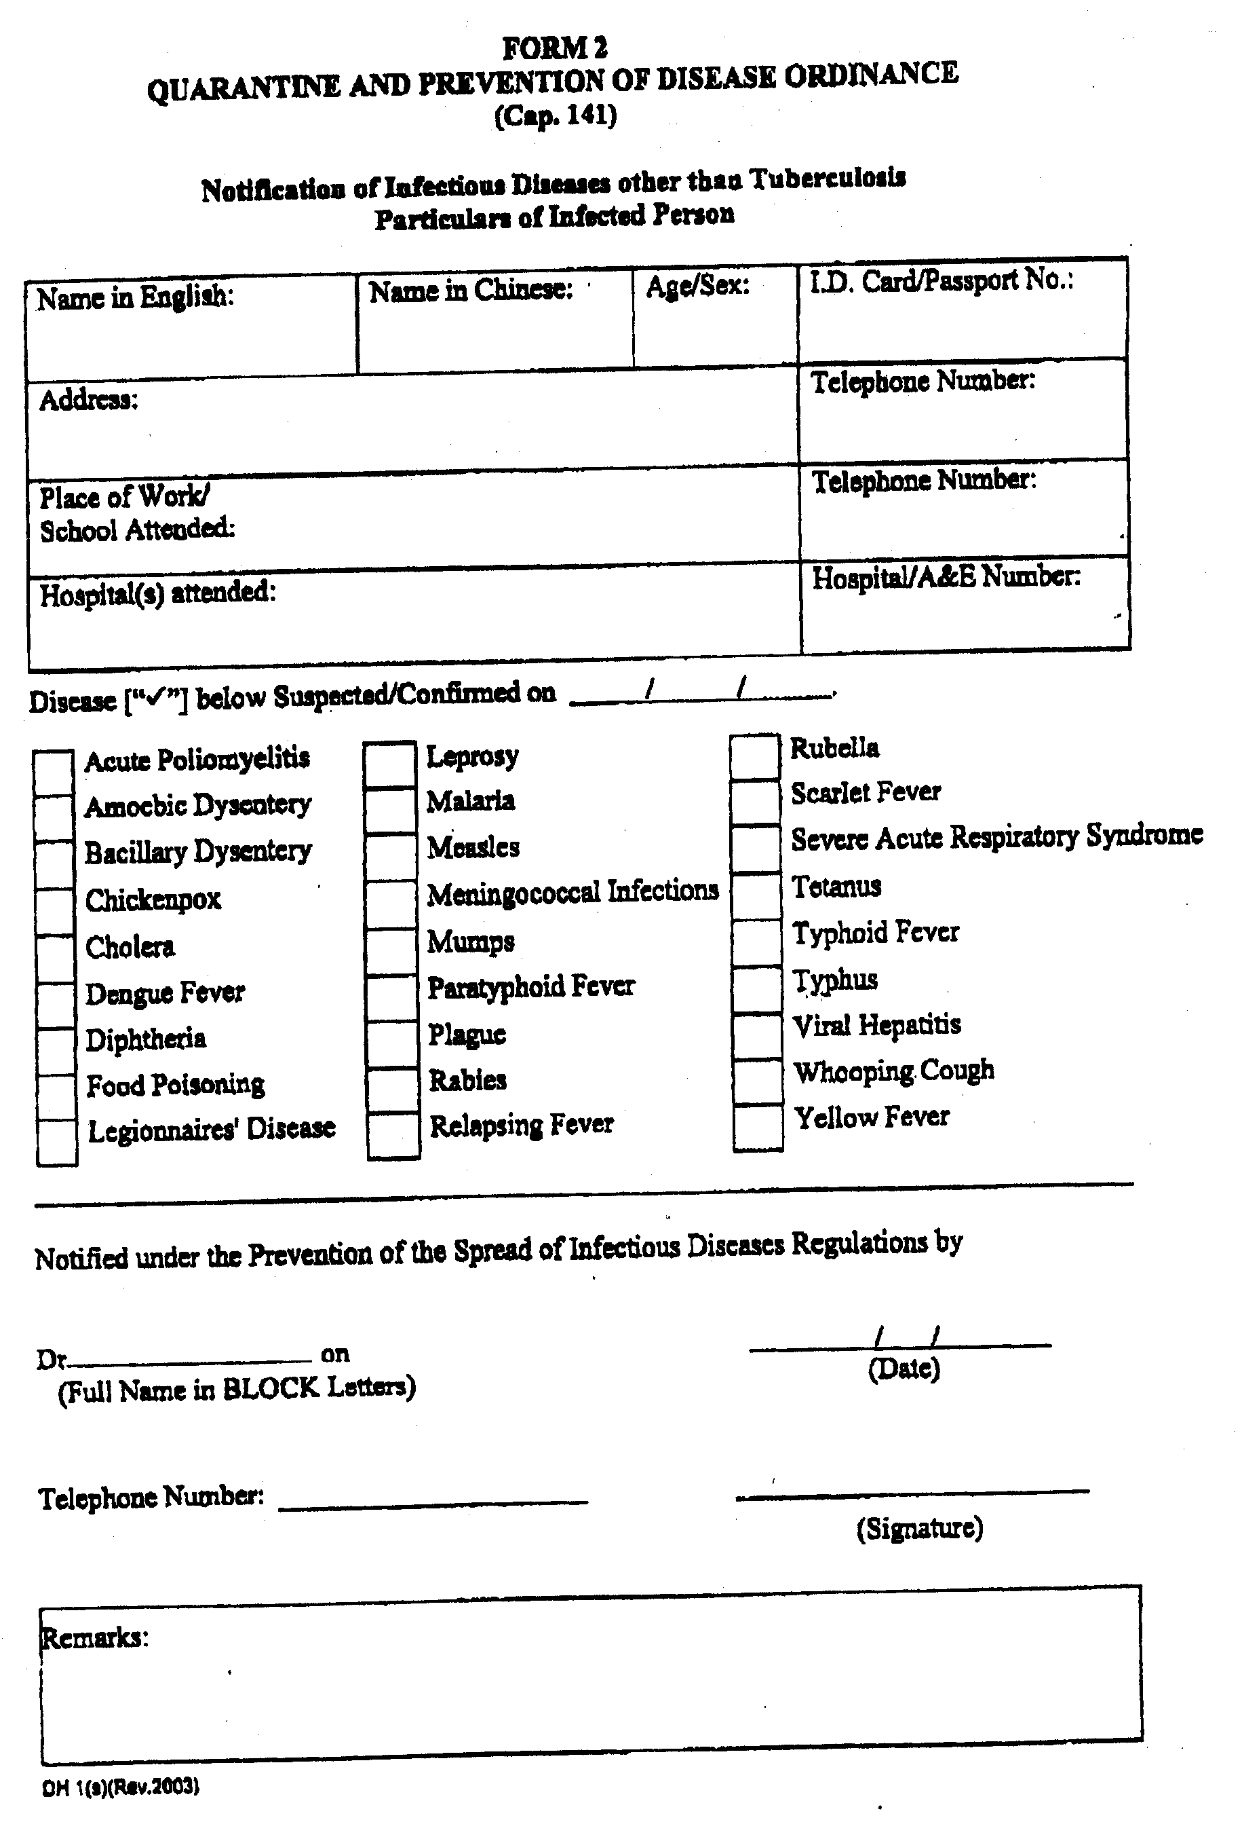
Annex 4
Report Form for Dengue Fever/Japanese Encephalitis*
* Please delete as appropriate

From : ___________________ Hospital  Date : ____________________  Reported by : _______________________________ (Name & Post)  _______________________________ (Contact telephone number) | This form should be send to the following:  (1) Department of Health Regional Offices  Fax no. : (HK : 2572 7582) (Kln - 2375 8451)  (NTE: 2699 7691) (NTW: 2439 9622)  (2) Secretariat, Central Committee on Infection Control, HAHO  (Fax no : 2881 5848)  (HA intranet mail : “Secretariat of Central Committee on Infection Control”)

Name in English (pls affix patient gum label) | Name in Chinese | Sex/ Age | Home address | Place of work/ school attended | Confirmed/ Suspected cases | Date of A&E attendance | Date of admission | Onset date of fever and/ or symptom (pls also specify the symptom so identified) | History of travel  (place & duration) | Remarks

Acknowledgement chop by CCIC Secretariat. Date:

